Subscription process in CaTH: Subscription by Case name process and Subscription by case reference number, case ID or unique reference process
Subscription by case name
Screen 1: add subscription by case name
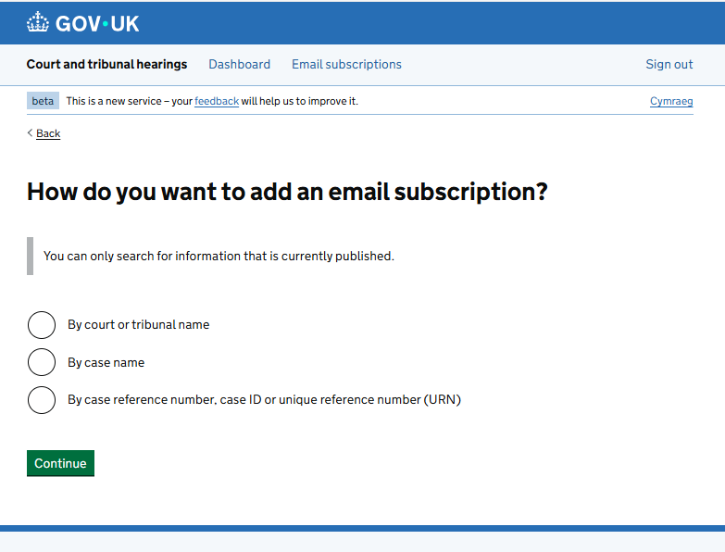

Screen 2: insert case name
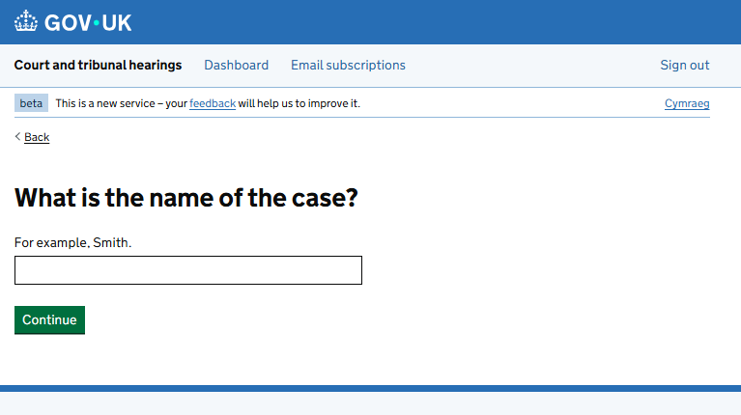

Screen 3: Error message when user puts in the wrong case name
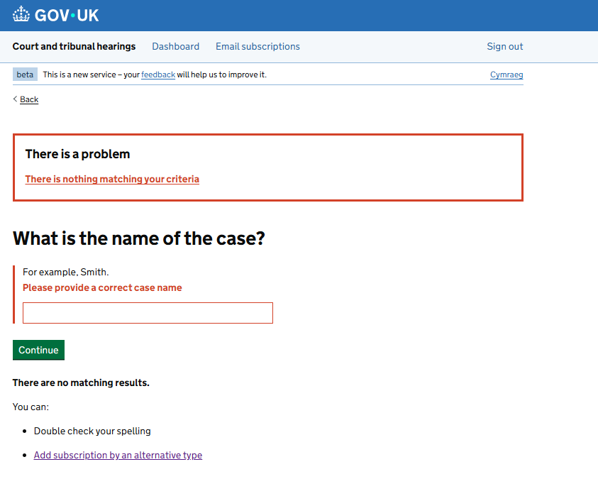

Screen 4: search results
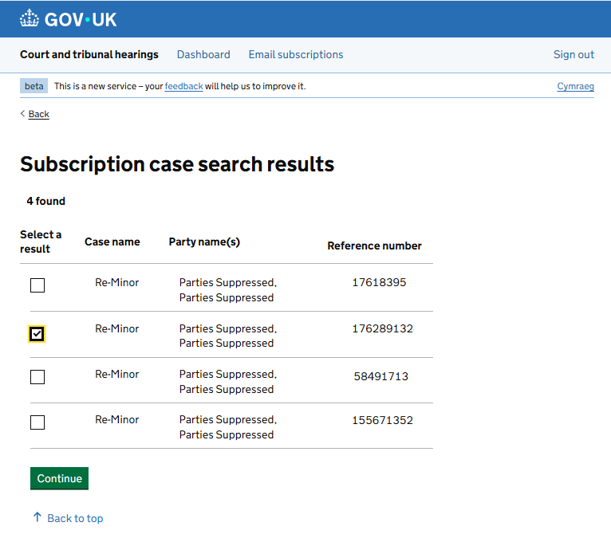
Screen 5: confirm email subscriptions
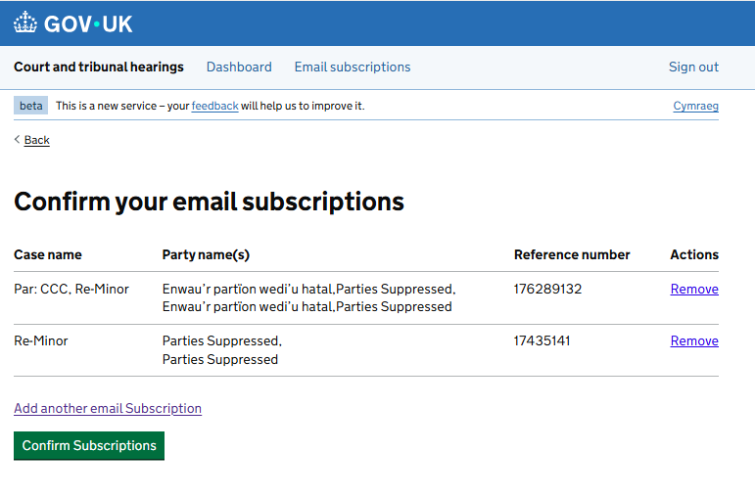
Screen 6: subscription confirmation


Screen for subscription By case reference number, case ID or unique reference number (URN)
Screen 1: add subscription by reference number, case ID or unique reference number
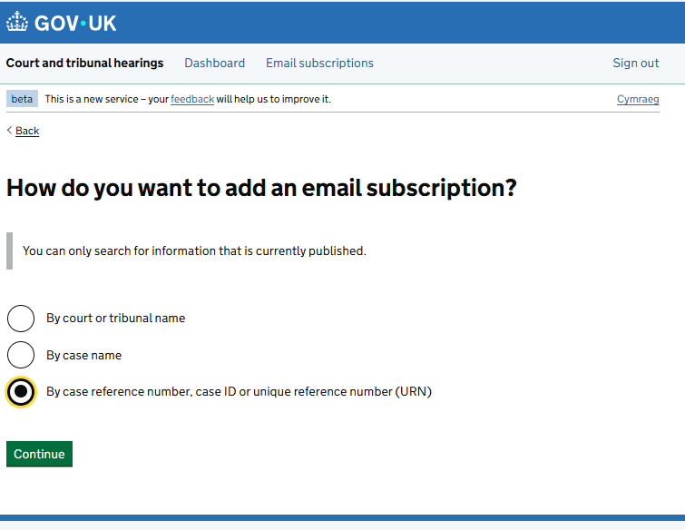

Screen 2: add case reference number
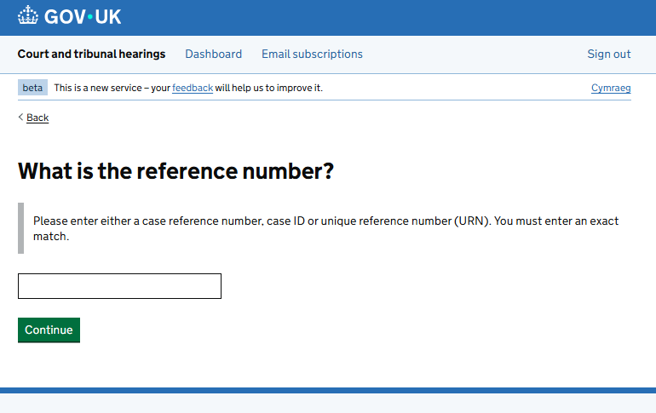
Screen 3: error message when user puts in the wrong case reference
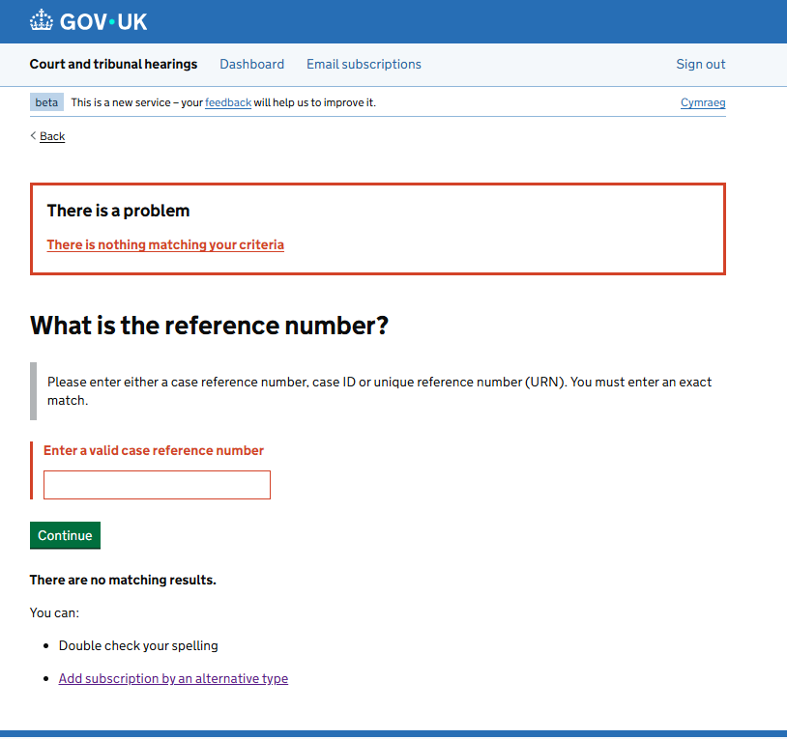

Screen 4: search results
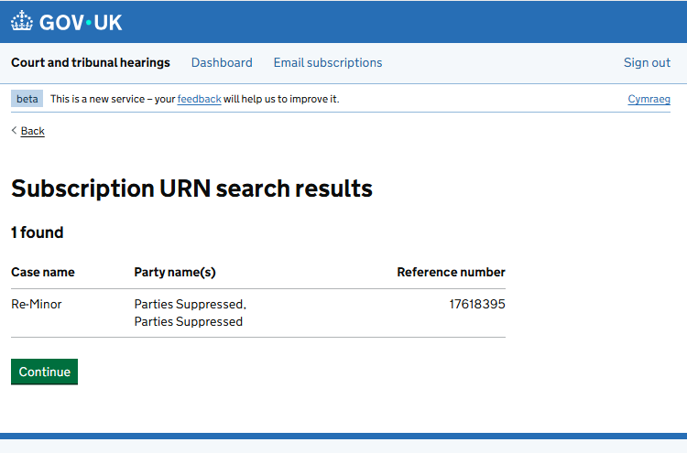
Screen 5: confirm email subscriptions
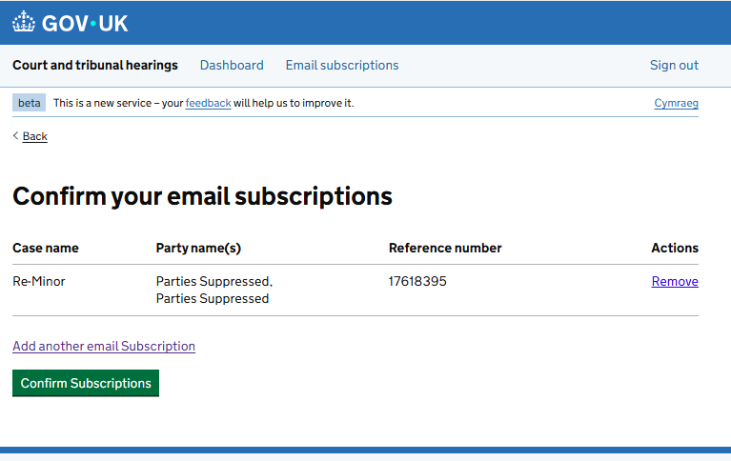
Screen 6: subscription confirmation


